TEKHNĒLOGIA

Muhammad Azhad bin Zuraimi, Muhammad Fitri bin Hanafi, Mohammad Syazwan bin Mazli Shahar  
*Faculty of Electrical Engineering*

Universiti Teknologi MARA Shah Alam

40450 Shah Alam, Selangor.

Email: [azhadzuraimi@gmail.com](mailto:azhadzuraimi@gmail.com), [fitribinhanafi@gmail.com](mailto:fitribinhanafi@gmail.com), [syazwanmazli@gmail.com](mailto:syazwanmazli@gmail.com).

Abstract—People want recent news about music, games, movies and gadgets. Because in Malaysia thus all-pack multimedia does not have famously known. This website is built to engage user-ends info about their favorites band music, how playthrough in recent gaming titles, all specification of decent gadgets, and total review blockbuster movies from Malaysian perspective reviewers. This is a website for young enthusiast lovers of multimedia.

Keywords— movies, music, games, gadgets, reviews.

# **Introduction**

Hypertext Markup Language or HTML is a standard language that requires memorization of a dozen of HTML commands for being used to create and designed the websites. It can be assisted with Cascading Style Sheets (CSS) and scripting language such as JavaScript. By using HTML editor such as Adobe Dreamweaver or text editor such as Notepad or WordPad, we are ready to begin setting up the website that we want. Other than using the HTML editor or text editor that require a person to build the website from scratch, using design templates offer numerous advantages and more efficient. It can save money, save our time and immediate results. Building a website from scratch can be very painful and frustrating experience, due to the amount of time required to write the code. However, web design templates can save a lot of times since they are already coded thus reducing the amount of customization word required. Other than that, a well-coded web design templates will be easier to be manage and can be publish anytime without any delay. Nowadays, the newest version of the language is HTML5. The differences between the HTML5 and HTML is that it supports both audio and video whereas none of these was a part of HTML. HTML5 also provides full support for JavaScript to run in background while HTM doesn’t. There are also supports for new kind of form control such as dates and times, email, number, range, search and new elements such as summary, audio, details, embed, footer, header etc.

# **Objectives**

The main objective of this project is:

1. To introduce latest news about music, games, gadgets, and movies.
2. To reviews about music, games, gadgets, and movies.
3. To give opinion about music, games, gadgets, and movies.

# **Literature review**

I. **Introduction**

With the uprising of web development sensation, people from around the World uses websites for certain purposes from online encyclopedias to e-commerce businesses. According to Robert Cailliau (2000) **[1]**, On 30 April 1993, CERN announced that the World Wide Web would be free to use for anyone. Before the introduction of HTML and HTTP, other protocols such as File Transfer Protocol and the gopher protocol were used to retrieve individual files from a server. These protocols offer a simple directory structure which the user navigates and where they choose files to download. Documents were most often presented as plain text files without formatting or were encoded in word processor formats. Internet usage has increased tremendously and rapidly in the past decade **[2]**. Websites have become the most important public communication portal for most, if not all, businesses and organizations. As of 2014, 87% of American adults aged 18 or older are Internet users **[3]**. Because business-to-consumer interactions mainly occur online, website design is critical in engaging users. **[2]** Poorly designed websites may frustrate users and result in a high “bounce rate”, or people visiting the entrance page without exploring other pages within the site (Google.com, 2015). On the other hand, a well-designed website with high usability has been found to positively influence visitor retention (revisit rates) and purchasing behavior. [1]

This review sought to address that question by identifying and consolidating the key website design elements that influence user engagement according to prior research studies. This review aimed to determine the website design elements that are most commonly shown or suggested to increase user engagement. **[4]** Based on these findings, students listed and defined a short list of website design elements that best facilitate and predict user engagement. The work is thus an exploratory research providing definitions for these elements of website design and a starting point for future research to reference. **[5]**

II. **Materials and Methods**

Students searched for articles relating to website design on Google Scholar (scholar.google.com) because Google Scholar consolidates papers across research databases (e.g., Pubmed) and research on design is listed in multiple databases by using the following combination of keywords: design, usability, and websites. Google Scholar yielded 115,000 total hits. However, due to the large list of studies generated, students decided to only review the top 100 listed research studies for this exploratory study. **[5]** Our inclusion criteria for the studies was: (1) publication in a peer-reviewed technology journal, (2) publication in English, and (3) publication in or after 2000. Year of publication was chosen as a limiting factor so that we would have enough years of research to identify relevant studies but also have results that relate to similar styles of websites after the year 2000. The students also included studies that were experimental or theoretical (review papers and commentaries) in nature. Resulting studies represented a diverse range of disciplines, including human-computer interaction, marketing, e-commerce, interface design, cognitive science, and library science.

In other words, the students used Strikingly as a domain website to promote a review page for modern reading purposes. The title of the website is “tekhnēlogia” which are two words with separate meaning in Greek, “tekhnē” means art or craft and “logia” means logic. When both words combine, it becomes a systematic treatment. The website includes reading materials that reviews latest movies, games, songs and gadgets. The website provides simple and minimal layout page to make it easier for users and readers to read the articles in specific pages. **[4]** The layout design of the webpage is important for editors to assemble and edit the articles with no complications met.

III. **Comparison to Other Existing Websites**

Websites like Reddit, TechNave, Spotify and Metacritic require a specific account for each website to login. With the new website developed by the students, no specific account login for different uses required. To post review, users are only required to login through Facebook account, which it safe and user-friendly. This is to avoid multiple account registrations for users and with the developed website, everything is accessible with one Facebook account connected to the webpage desired. The purpose of the website is to review and give opinion about the latest updates on movies, games, songs and gadgets before users decide on what to do or give their own specific ideas as a way of sharing knowledge for everyone. **[6]**

Moreover, the developed website also has a subscription letterbox function for users who are interested in knowing the latest news and updates available on the website. The layout design of the website is simple and minimal compared to other review websites which have advertisement tabs all over the webpage and complicated functions. **[3]** Users can also give their opinions on the review and opinion box on each post so everyone can read and reply to the opinions stated on the post. **[8]** With this function, editors and users can learn positive outputs throughout the opinions given for better and positive ongoing changes of a review website.

# **Methodology**

## Flowchart

Figure 1: Project Flowchart 1

Figure 1 Shows the flowchart of tekhnēlogia works from first main home webpage.

Figure 2: Project Flowchart 2

Figure 2 Shows the flowchart of tekhnēlogia works from movies main webpage.

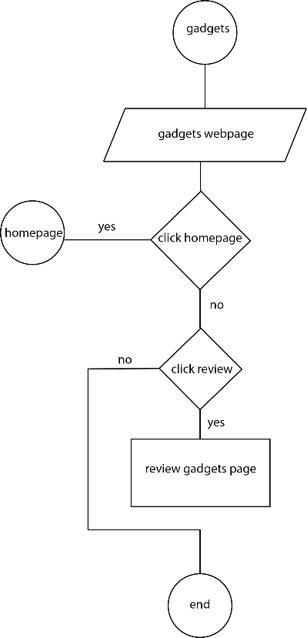

Figure 3: Project Flowchart 3

Figure 3 Shows the flowchart of tekhnēlogia works from gadgets main web page.

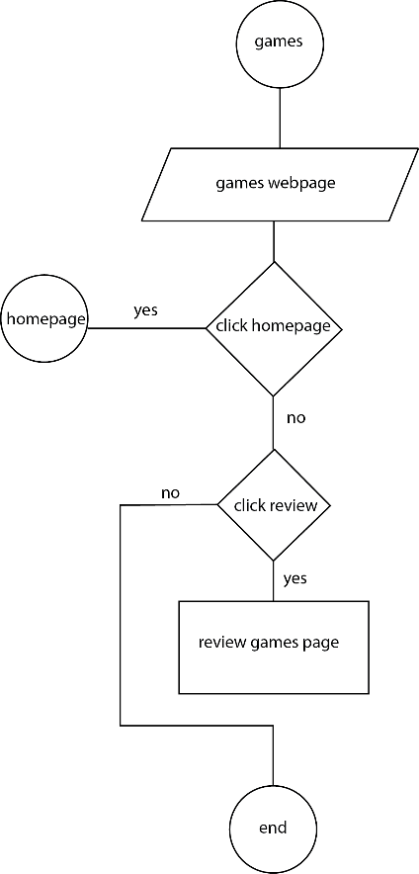

Figure 4: Project Flowchart 4

Figure 4 Shows the flowchart of tekhnēlogia works from games main web page.

Figure 5: Project Flowchart 5

Figure 5 Shows the flowchart of tekhnēlogia works from music main web page.

## Software

Certain software is used to build website. Usually, programmers will use html with CSS and Java. To reduce times and searching for attractive webpage build, so programmer use strikingly. Programmer use strikingly template for making website. Had to choose an interactive and engaging interface.

1. 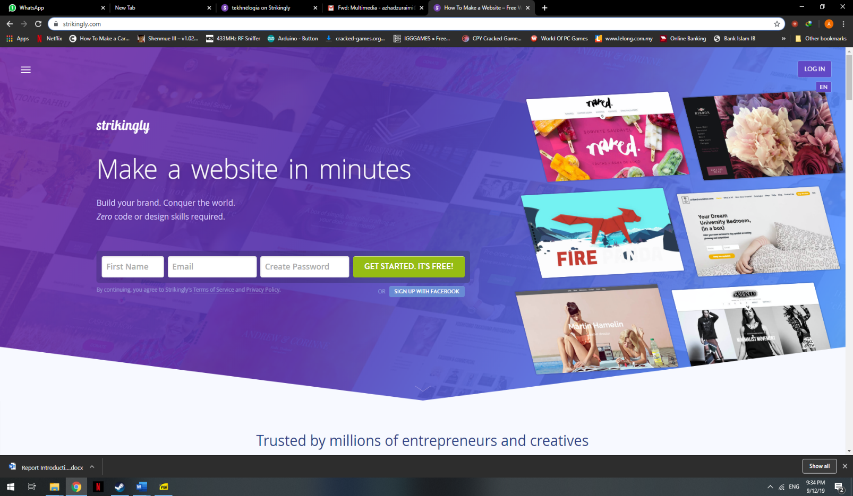**Strikingly**

Figure 6: Strikingly Homepage Website

Figure 6 shows the main homepage website strikingly used for hosting and editing our webpage.

1. **Requirement analysis**

Our project targets people that read recent news about gadgets, movies, games and musics. To analyse what kind of website that need to be produced, research had been done showed how other reviewers website producers such as Metacritic, TechNave and CNet.

1. **Web-page conceptualization**

Figure 7: composite structure of website

Figure 7 shows the concept on our website design structure is composite. website had been justified every single aspect of the design to ensure that each element is serving a specific need and the website is truly designed to attract, retain and enhance the end user-experience. Website had been developed custom built with high-end website design templates and concepts by strikingly. Many thought processes and brainstorming had gone through into this process to create a design that is serving user needs as well as is sustainable with the future growth.

1. **Brand**

Our brand needs to concept that refer to the modern era technology. The word technology comes from two Greek words, transliterated techne and logos. Techne means art, skill, craft, or the way, manner, or means by which a thing is gained. Logos means word, the utterance by which inward thought is expressed, a saying, or an expression. So, literally, technology means words or discourse about the way things are gained. So, our branding name is tekhnēlogia.



Figure 8: Tekhnēlogia logo

Figure 8 shows the logo use as symbol for our webpage and use as click button to our home main page.

1. **Logo**

Our logo needs to be concept that refer to the technology. Thus, we use phone as an icon that famous in today modern era. WiFi logo was picked to show reception of fundamental internet in today era. Dot icon to show chatting and conversation that famous and gossips about nowadays technology. Red with contrast with white colors was chosen as engaging and bold colors.

1. **Subscription**

Our websites had subscription option for end-user to get frequent update about our website conversation and updates about movies, gadgets, music, and games.

1. **Feedback**

Our websites had feedback for helping owners to identify issues and solve them. owners would manage feedback in a positive way so that it can help improve and grow your business.

1. **Contact info**

Contact info such as email, phone numbers, map location of business is given for business and end user to contact for more information about details or business for the websites to improve and acknowledge.

1. **History**

The founding of the tekhnēlogia website is synopsis telling in webpage for giving info to newcomer and curious fans of the webpage. The contributors were introduced in webpages for credits.

1. **Web hosting**

The web hosting that been using is from strikingly. The main page web hosting for this website is <http://tekhnelogiaofmodernera.mystrikingly.com/>.

# **result and analysis**

Website had 5 main webpages. Firstly, the homepage to introduce logo, history, contributors, point of view and contact. Secondly, the games webpage. Next, is music webpages, and gadgets webpages. Lastly, movies webpage.

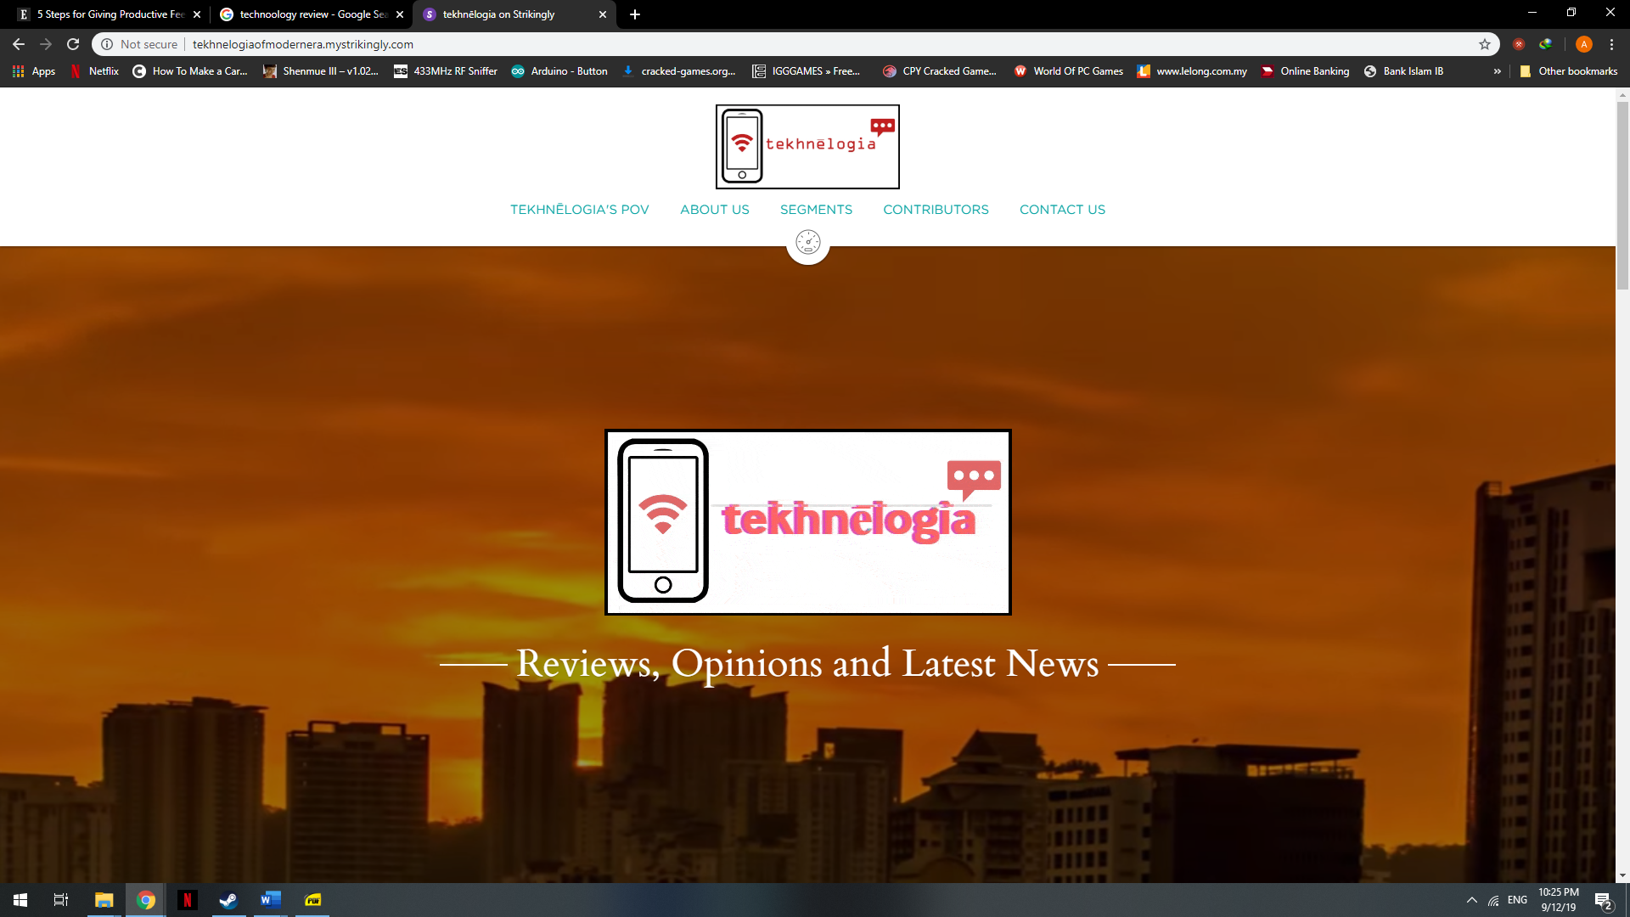

Figure 9: Tekhnēlogia Front Page

Figure 9 shows the Tekhnēlogia Front Page interface with end user.

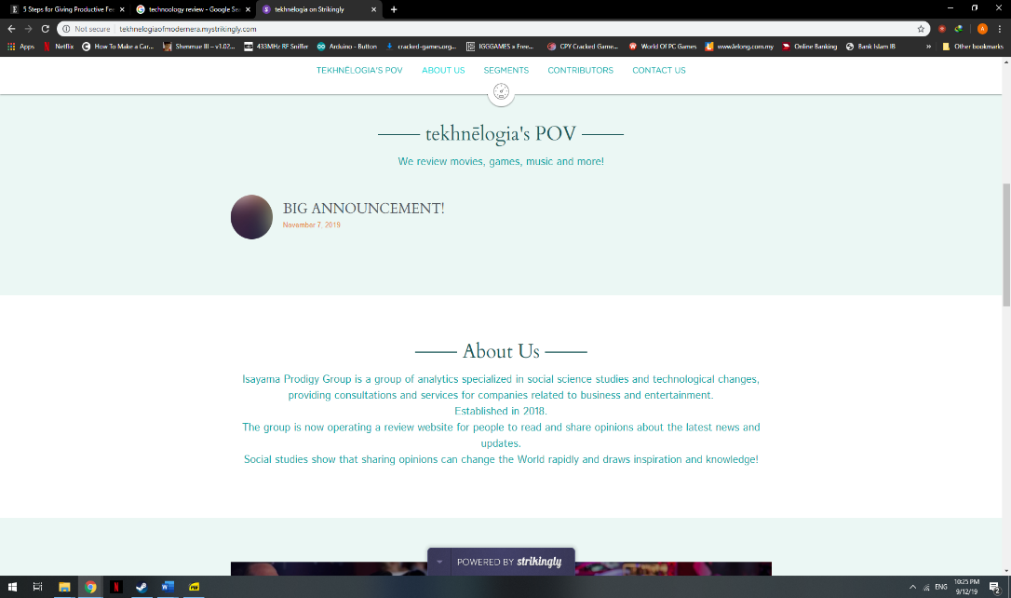

Figure 10: POV and About Us Page Section

Figure 10 shows the pov and aboust us page section to tell end-user about new update and history founding about Tekhnēlogia web .

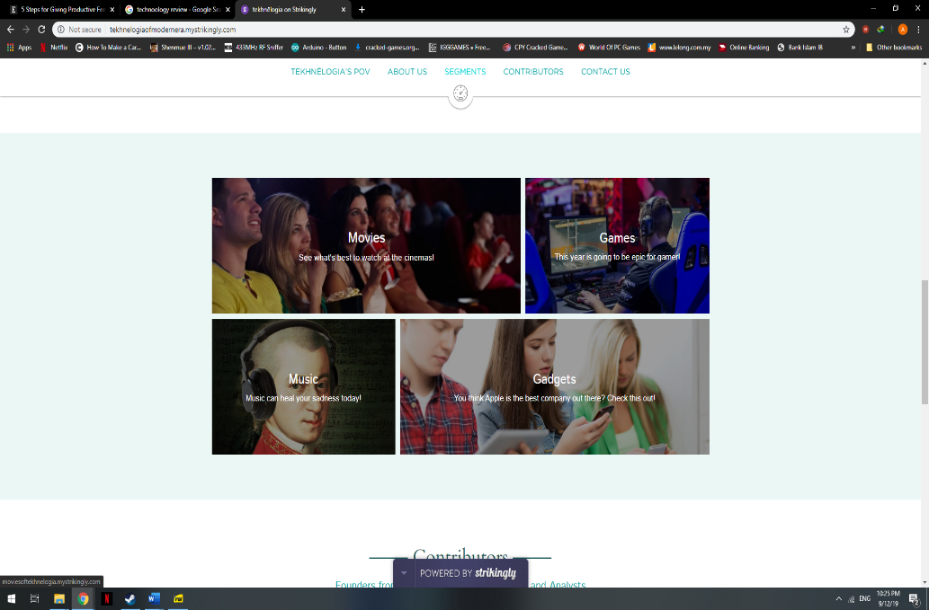

Figure 11: Interactive Animation Linked Webpage

Figure 11 shows segment for link to main objective of this websites which are music, movies, games and gadgets review.

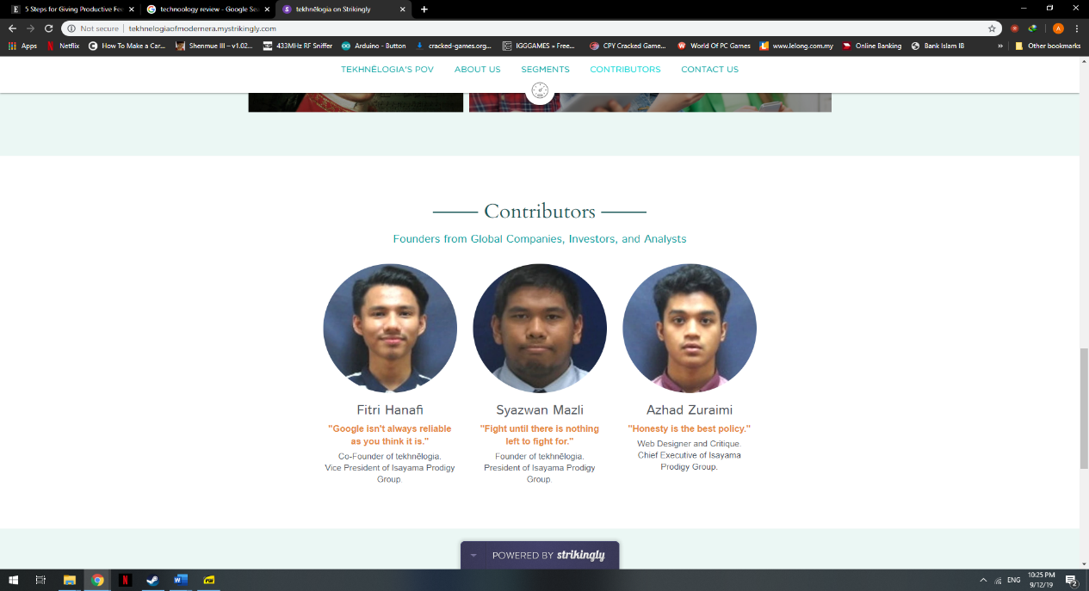

Figure 7: Company Profile

Figure 12 shows the contributors to Tekhnēlogia web page.

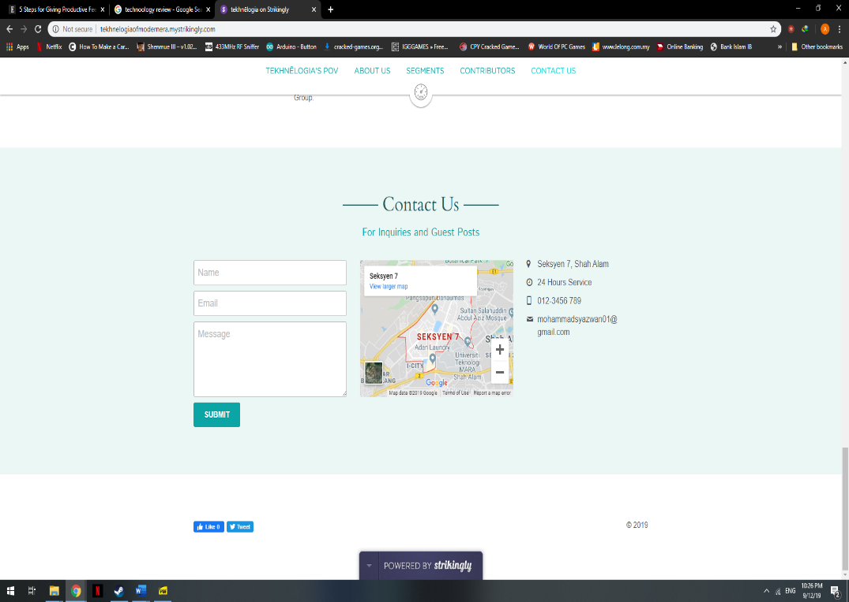

Figure 13: Contact Us letterbox

Figure 13 shows the contact us letterbox for user-end to contact contributors.

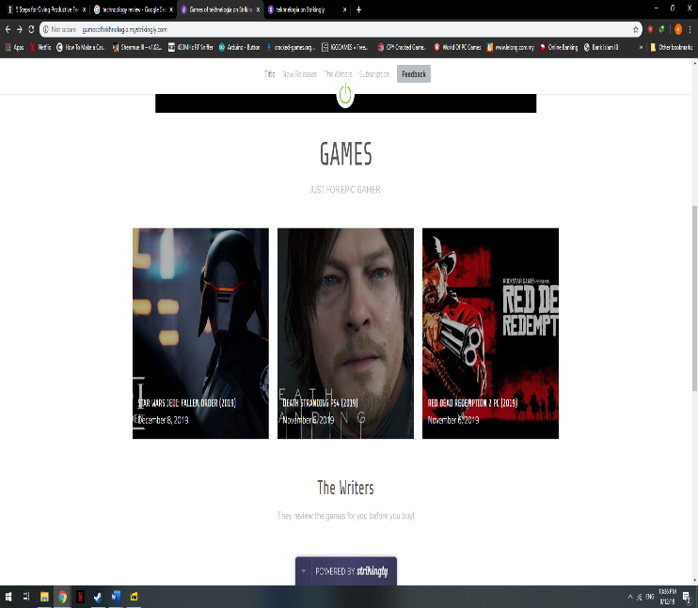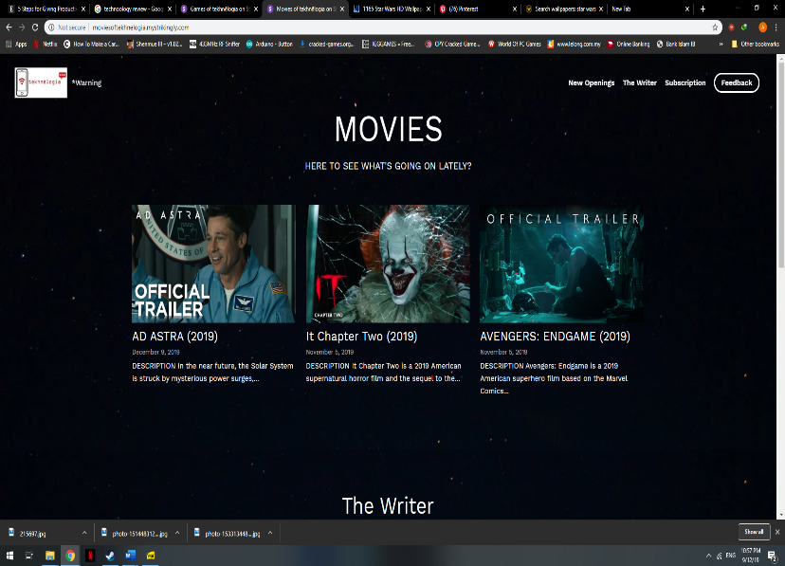

Figure 14: Game Webpage

Figure 14 shows the main page of game webpage.

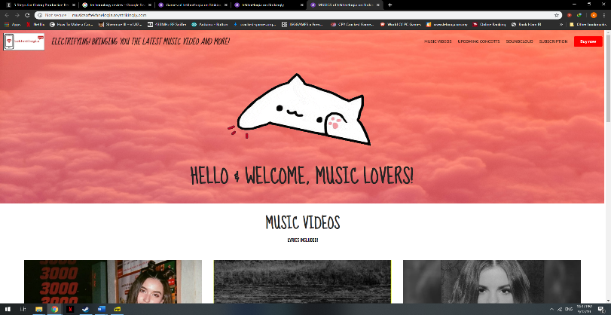

Figure 15: Music Webpage

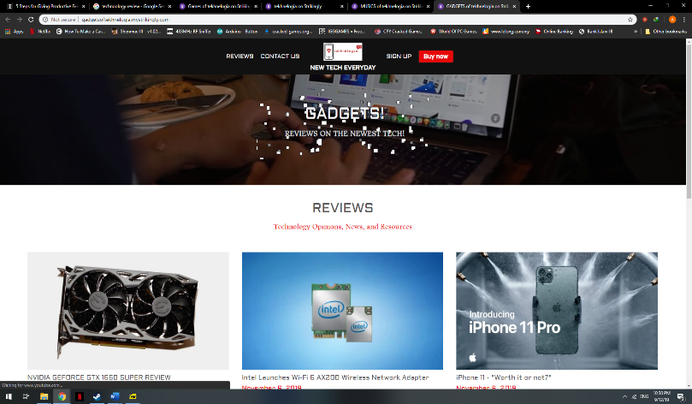Figure 15 shows the main page of music webpage.

Figure 16: Gadget Webpage

Figure 16 shows the main page of gadget webpage.

Figure 17: Movie Webpage

Figure 17 shows the main page of movie webpage.

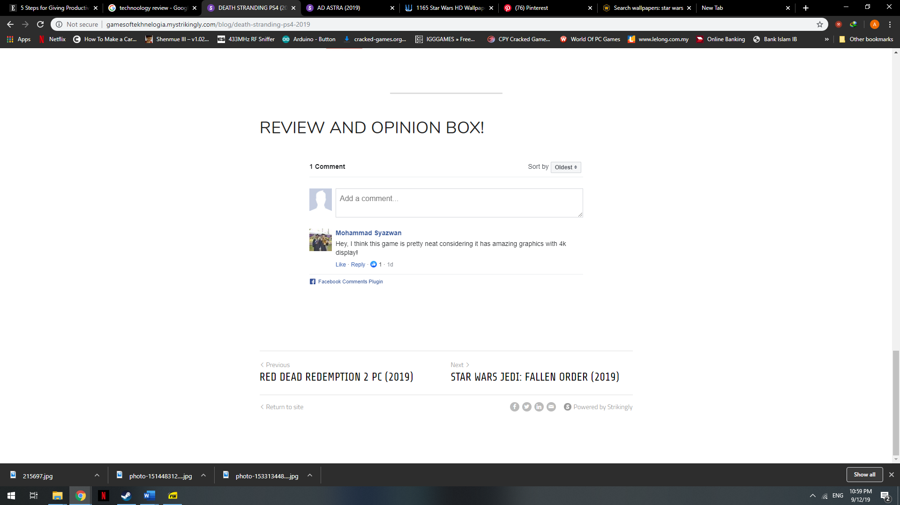

Figure 18: Review and Opinion Box

Figure 18 shows the result taken by end-user engaging with this website is given below in review and opinion box.

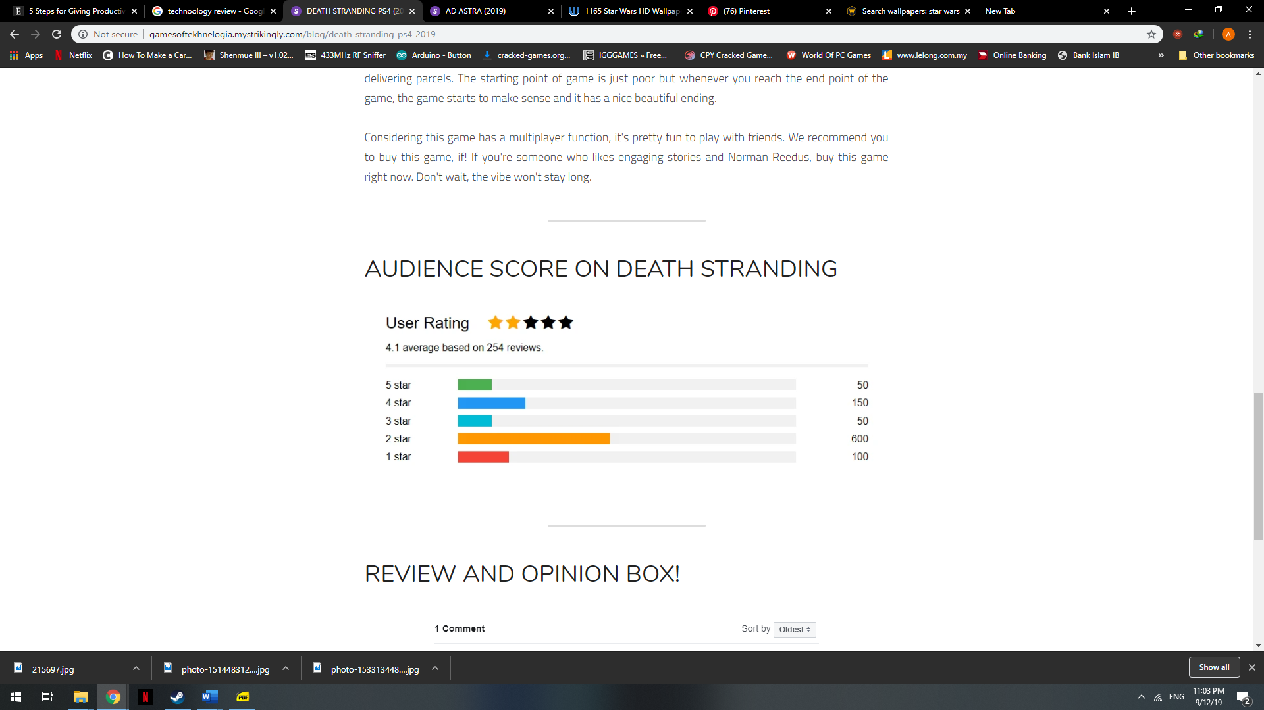.

Figure 14: Audience Score Rating

Figure 19 shows nalysis taken with end-user about the websites for example the death stranding game by audience and other reviewers.

# **conclusion**

As for conclusion, HTML is very important in building and designing a website along with CSS and JavaScript. The students can learn on how to use the HTML to create and design their website with animations, pictures, audio notes, videos and texts. Knowing basic HTML is a skill that will help the students with blogging, working with Wiki's, Facebook, and much more. Through evaluating many different web sites, the students also are aware of what is effective and ineffective to viewers when designing a website too. By that way, the website will be more interactive and interesting for the guest to use it.

Other than that, by using this language along with design templates will make it easier for the students to create a website, rather than doing it from scratch. The student can determine that using templates can save the time, because it can reduce the amount of time to customize the HTML from scratch according to what the students need.

Next, the students manage their website easily and publish it anytime without any delay, thus making them finish designing the website on-time. Lastly, the student can distinguish the differences between HTML and HTML5, while learning that HTML5 is far better than HTML.

# **Acknowledgment**

##### The authors would like to thank to lecturer, Dr Lucyantie Binti Mazalan and the Faculty of Electrical Engineering members for supporting and guidance shown in making the project. Also, parents’ authors for funding and encouraging authors.

##### **References**

1. Gillies, James; Cailliau, Robert (28 September 2000). [How the Web Was Born](https://archive.org/details/howwebwasbornsto00gill). Oxford University Press. p. 197.
2. Bureau of Labor Statistics, U.S. Department of Labor. ["Information Security Analysts, Web Developers, and Computer Network Architects"](http://www.bls.gov/oes/2011/may/oes151179.htm). *Occupational Outlook Handbook, 2012-13 Edition*. Retrieved 2013-01-17.
3. Perrin, Andrew; Anderson, Monica (April 10, 2019). ["Social media usage in the U.S. in 2019 | Pew Research Center"](https://www.pewresearch.org/fact-tank/2019/04/10/share-of-u-s-adults-using-social-media-including-facebook-is-mostly-unchanged-since-2018/). *PewResearch.Org*. Pew Research. Retrieved July 20,2019.
4. [Berners-Lee, Tim](https://en.wikipedia.org/wiki/Tim_Berners-Lee); [Connolly, Daniel](https://en.wikipedia.org/wiki/Dan_Connolly_(computer_scientist)) (June 1993). ["Hypertext Markup Language (HTML) Internet Draft version 1.2"](https://www.w3.org/MarkUp/draft-ietf-iiir-html-01.txt). IETF IIIR Working Group. Retrieved 18 September 2010.
5. Spiesser, J., Kitchen, L.: Optimization of HTML automatically generated by WYSIWYG programs. In: 13th International Conference on World Wide Web, pp. 355—364. WWW '04. ACM, New York, NY (New York, NY, U.S., May 17–20, 2004)
6. Tim Berners-Lee, James Hendler and Ora Lassila (2001). ["The Semantic Web"](http://www.scientificamerican.com/article.cfm?id=the-semantic-web). *Scientific American*. Retrieved October 2, 2009.
7. Raggett, Dave (2002). [*"Adding a touch of style"*](https://www.w3.org/MarkUp/Guide/Style.html). W3C*. Retrieved October 2, 2009*. This article notes that presentational HTML markup may be useful when targeting browsers "before Netscape 4.0 and Internet Explorer 4.0"
8. Tim Berners-Lee (December 9, 1991). ["Re: SGML/HTML docs, X Browser (archived www-talk mailing list post)"](http://lists.w3.org/Archives/Public/www-talk/1991NovDec/0020.html). Retrieved June 16, 2007. SGML is very general. HTML is a specific application of the SGML basic syntax applied to hypertext documents with simple structure.